Experiment # 3

Answer 1:

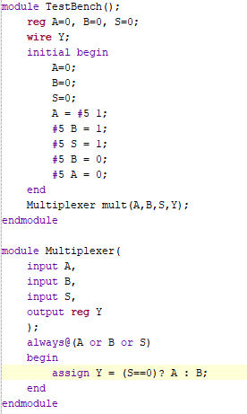
Module (Code)

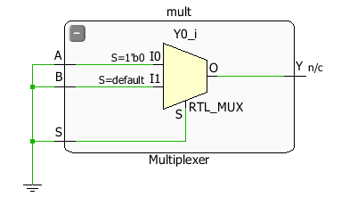
Schematic synthesis

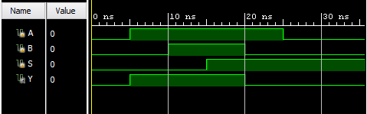
Output Waveform

Answer 2:

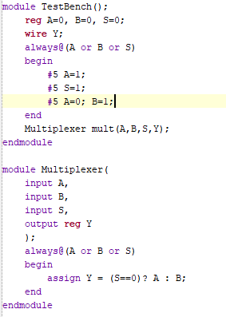
Module (Code)

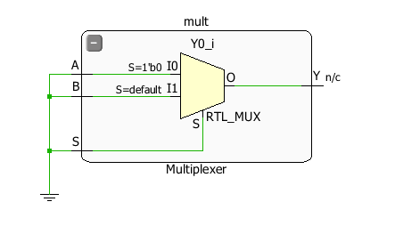
Schematic synthesis

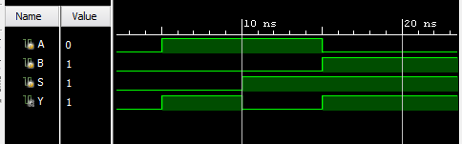
Output Waveform

Answer 3:

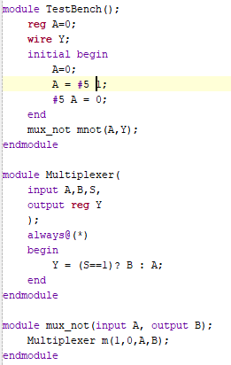
Module (Code)

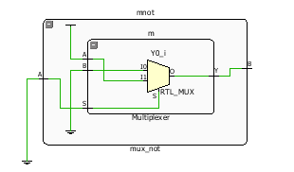
Schematic synthesis

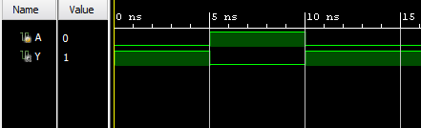
Output Waveform

Answer 4:
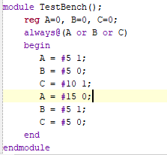
Module (Code)

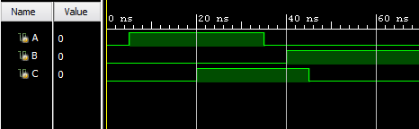
Output Waveform

Answer 5:
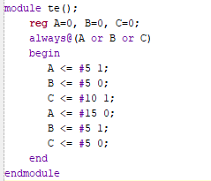
Module (Code)

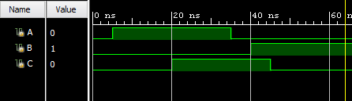
Output Waveform

Answer 6:
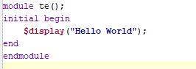
Module (Code)

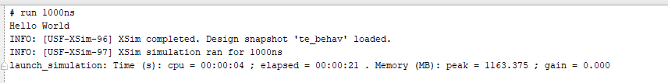
Output

Answer 7:

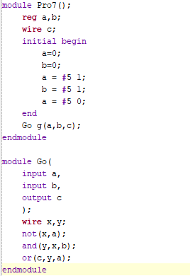
Module (Code)

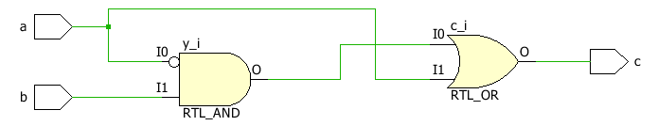
Schematic synthesis (Gate level)

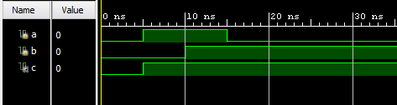
Output Waveform

Answer 8:

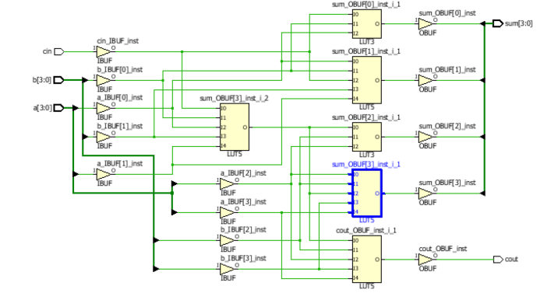
Schematic synthesis

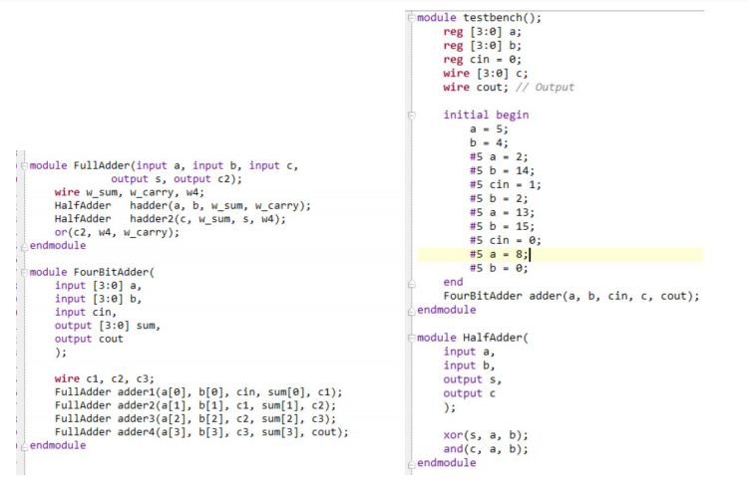
Module (Code)

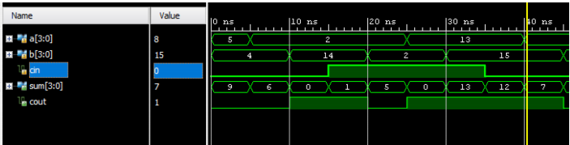
Output Waveform

